Transistor Light Dimmer

Introduction

This article shows you how to design and build a simple transistor light dimmer circuit.

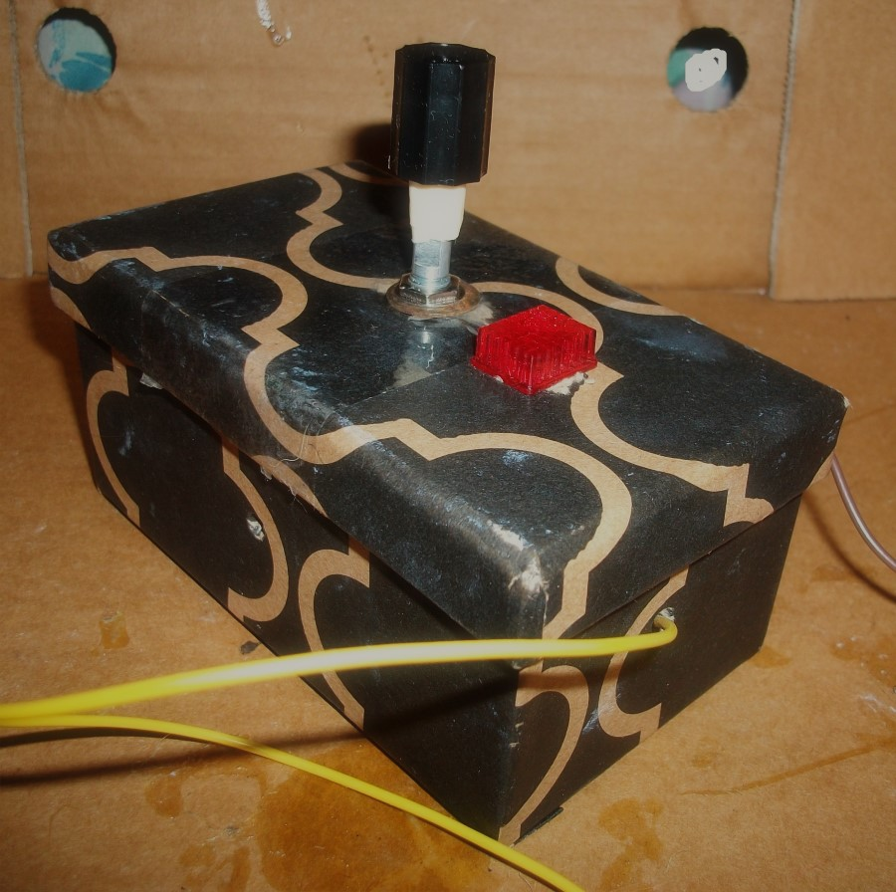
Figure 1: Transistor Light Dimmer.

Step 1: Design the Circuit

I used the PSpice student edition version 9.1 to reduce editing and simulation time. Rs resistor and Cs capacitor are optional components used to filter possible power supply oscillations.

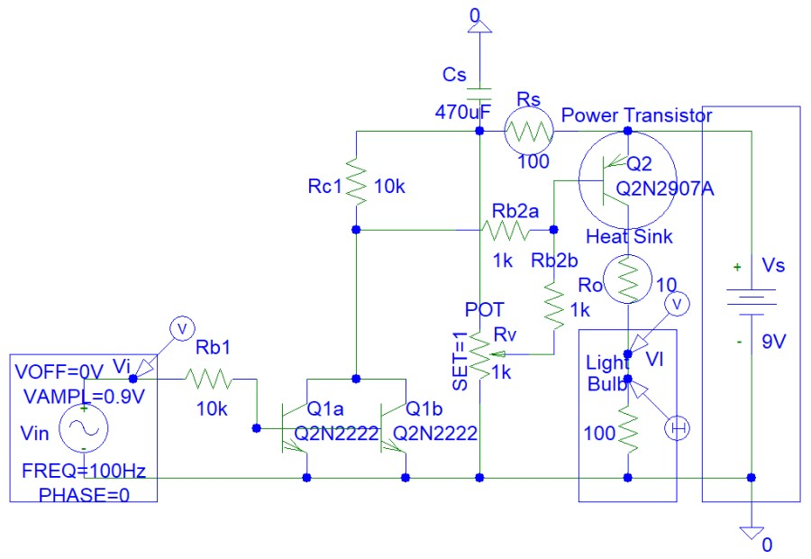
Figure 2: Circuit Design.

The circuit also has an input connection for controlling the brightness of the lamp via analogue input.

This circuit is made for high-current light bulbs or high-current LEDs. The brightness of low-current light bulbs (10 mA or 20 mA) or LED strips can be controlled with variable resistors, without the use of transistors.

Step 2: Make the Circuit

I made the circuit on a piece of cardboard to save money:

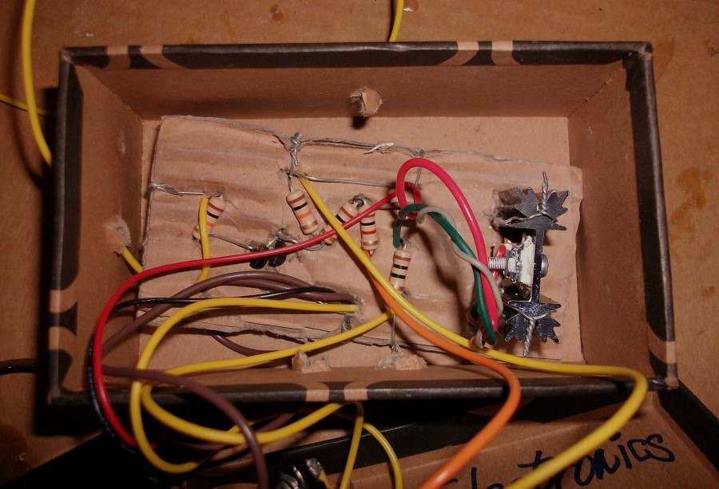
Figure 3: Make the Circuit.

I connected a 12 V, 100 mA light bulb that you will see on the next page.

I did not include the Rs resistor and Cs capacitor.

Step 3: Encasement

I place the circuit in a cardboard gift box.

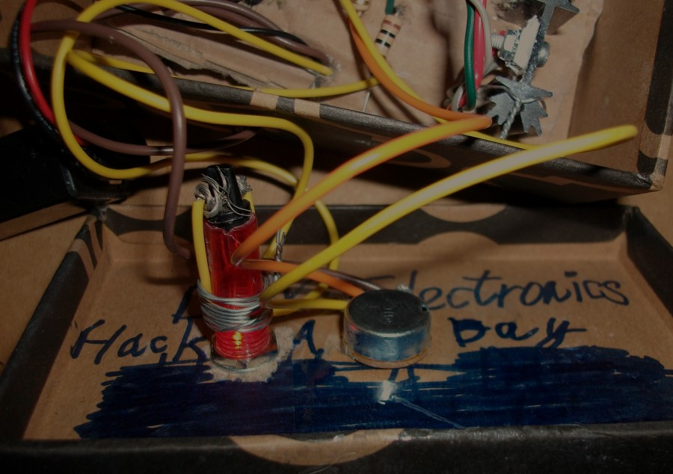
Figure 4: Encasement.

Step 4: Connect to Power Source

I connected a 9 V battery to the circuit as shown in the photo:

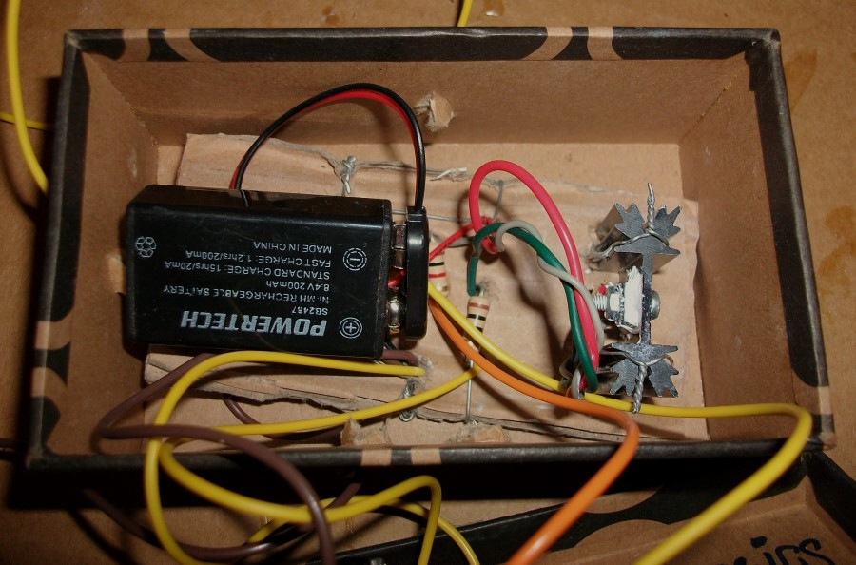
Figure 5: Power Source.

Step 5: Testing

I tested the circuit for light dimming but not audio input.

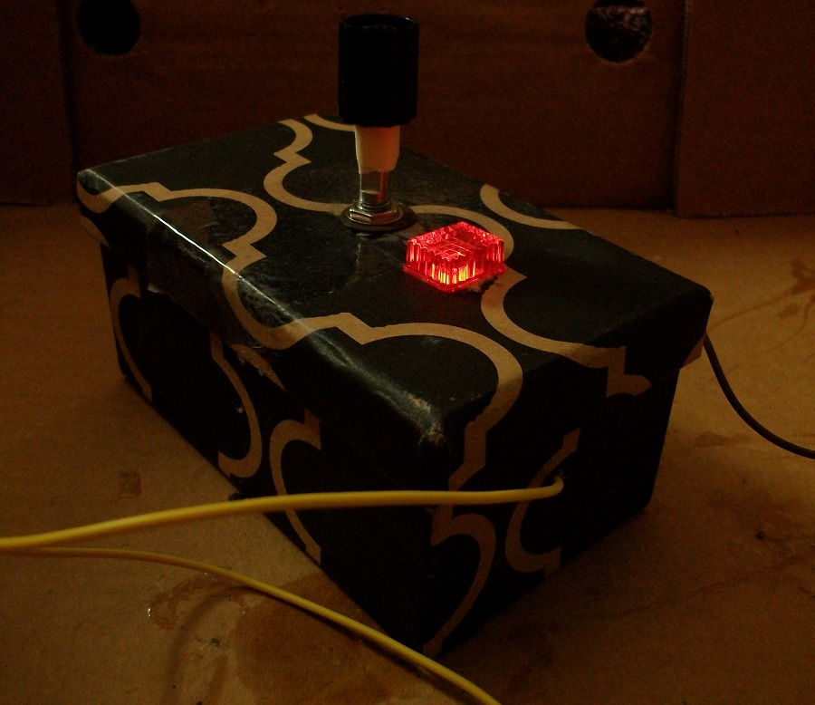
Figure 6: Testing.

Watch this video: https://www.youtube.com/watch?v=K4pFhfVWgKA

Conclusion

The circuit is a simple circuit that you can make to power 100 mA light bulbs. You can also use the same circuit to power higher-current light bulbs.

Eldo, Weird Circuits Project

